August 17, 2015

Dear Murch Teachers and Staff,

Welcome back! The Murch HSA is looking forward to another great year together. As a small demonstration of our gratitude for what you do for Murch students each and every day, the HSA is pleased to offer you the enclosed stipend to spend on supplies or materials that augment your teaching and the children’s learning. We hope this small token makes the start of the school year even better for you. This stipend comes with no strings attached and we don’t need any receipts.
Recognizing that this stipend will not cover larger classroom items or educational materials that might prove beneficial, we also offer a Teacher Grant Program. The Teacher Grant Program allows staff to request grant money for desired items to enhance your classroom or support your teaching that are not provided for by the DCPS budget.
As has been the case for the past few years, the requested items should be able to extend beyond the current year and should enhance the classroom experience for all children in the class. The requested items should also be aligned with the curriculum standards. This year resource teachers will also be eligible for teacher grants.

In an effort to make the process work when you need it, the HSA will offer two rounds of teacher grants this year. Grant guidelines and the application are attached, and will also be available on the Murch website. The first deadline for applications is Tuesday, September 15 at 5:00 pm. Any funds not awarded during this first application period will be made available during a second round of applications, due January 15, 2016 at 5:00 pm.

We look forward to working with you this year. If there is anything that we can do for you or you have any questions, please let us know at HSAMurch@gmail.com.

Sincerely,
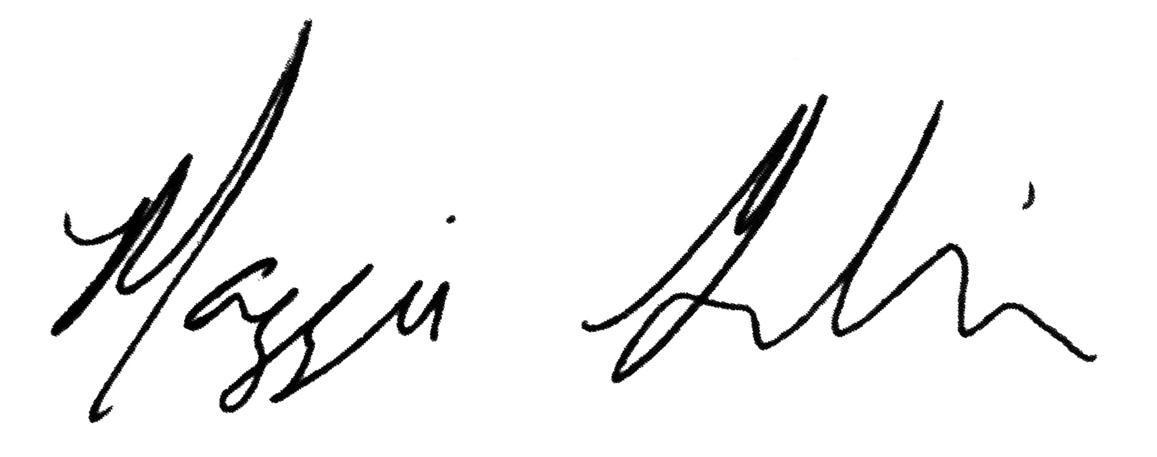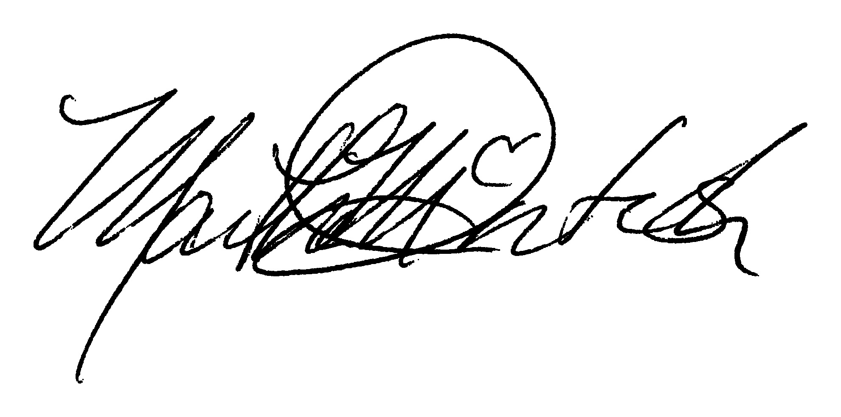

Maggie Gumbinner Martha McIntosh
HSA Co-President HSA Co-President

